Homework 1 for GPI
This is a problem set focused on single variable calculus, which is the basic math tools needed for the college physics. Some details are presented in the supplementary math notes (under supplementary I), so a reading on that part will be necessary for you to solve these problems if you do not know calculus before. The problem set is not needed to finish within this week but you can finish it within 2weeks

- Basic derivatives
- For function y=1/x, a) find its average change rate when x changes from 0.5 to 1. b) find its instantaneous change rate at x=0.5 and x=1.
- 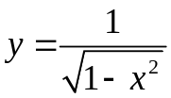, what is dy/dx?
- If x=sin(t) in the above function, what is dy/dt?
- For an hyperbola function: 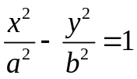
Find the derivative dy/dx with two different methods: a) Direct implicit differentiation by the equation. b) using parametric relation: 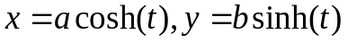, where 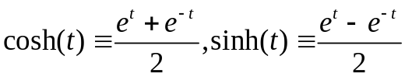
- For a curve given by 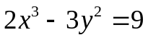, find the 2nd derivative of 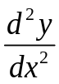. (Hint, using implicit differentiation)
- For a function 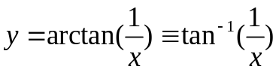, what is dy/dx?
- For 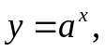is a constant, find dy/dx

- Related rate problems:
- Refer to the figure below:
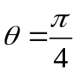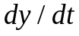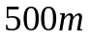
A car is moving along the road, and a police is hiding 500m from the road. The police is monitoring the speed of car by measuring the angular change rate of . If the 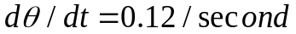at the moment shown in the figure, what is the speed of car?
(b) Hauling a boat:
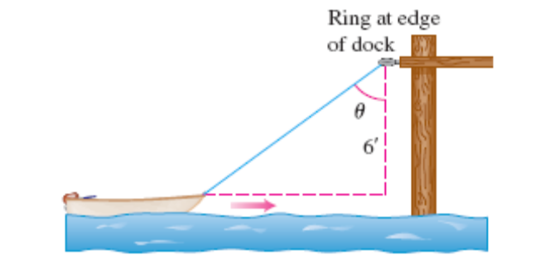
  - The boat is pulling towards the dock by a rope attached to its bow and through a ring that is 6 feet above boat. If the rope is hauled at a speed of 2 ft/s. What is the speed of the boat when the rope is 10ft long?
  - What is the angular changing rate of theta?
- Extremes
- The distance of a moving object is given by:
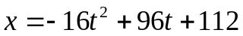 Find the its velocity at t=0, at x=0, and the maximum value of x and at what time this occurs?
- Shortest Beam:
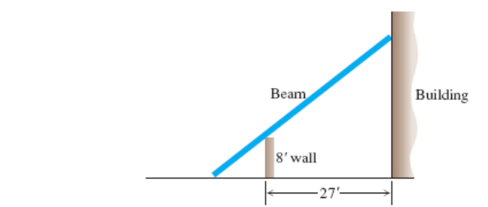
A 8-ft wall is 27 ft away from a building, what is the shortest length of a beam (a ladder) that can reach the building from the ground outside the wall?

- Limits and L’Hopital’s rules:
- Find limit of: 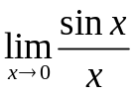
- Find limit of: 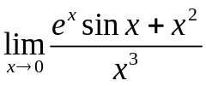

- Taylor expansion and accuracy on approximation
For a function given by: . The x is a small value |x|<<1. a) Using Taylor expansion to expressed the function as polynomial of x and keep the first 3 none zero terms. b) If x=0.1, approximate the function value (value of y) by taking only the 1st term; 1st and 2nd term; all 3 terms. And estimate the percentage of error by these approximations. The percentage of error can be defined as: (True Value-Approximation)/(true value) c) If x=0.01, repeat the above steps.

- The equilibrium position of load and tension of suspension rope:
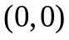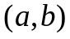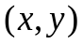
As the figure shows, a heavy load (a ring that can slide along the rope)with mass M is hanging on a massless rope, the length of rope is fixed at L and cannot be extended (the change of length of the rope by the load can be neglected). The supports of the rope (fixed ends) are shown in the figure. Find the equilibrium condition for the ring, i.e. where the ring finally settles along the rope, and prove that at this equilibrium, the tensional force along the left and right side of the rope are equal. (this is important for engineering, since you want the load equally distributed along the rope, if the tension along one side is much higher, then it is more likely breaking which is bad)
Hint: this problem is actually a finding the extreme locations, that the energy (potential) of the ring is the lowest or the y is smallest; x,y are not independent but under a constraint of fixed length L, from that using implicit differentiation, you will find the answer.

- The length of stacking blocks:

N identical blocks with uniform density are stacked together, each with length of 2m, and mass M. What is the maximum distance that these N blocks can reach without falling? If we want to use these blocks to built a span of 20m, approximately how many blocks are needed?
Hint: Much easier starting from the top (say set the top block left end as 0) and use property of center of mass (though I may not have formally introduced it, it is not difficult to grasp). The position of center of mass between two objects of masses M₁ and M₂ is:
X_{CM}=(M₁X₁+M₂X₂)/(M₁+M₂). The equilibrium (statics) requires that the center of mass of the top blocks has to be supported by the bottom one. You shall find the length goes as a famous series 1+1/2+1/3+… You may need calculus to estimate this series: 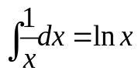.

- Basic Integration
- Find expression form for indefinite integral (antiderivative)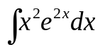 (Hint: integration by part)
- The density of the a round disk (for simplicity, just consider the unphysical 2-dimension case) is proportional to radius, i.e. 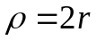. What is the total mass for the disk if the radius is R.
- Find the area between the x axis and the curve y=x², where x belongs [-1,+1], what is the area bound by the parabola and straight line y=1?
- Arc length of curves, where arc length ds can be computed:
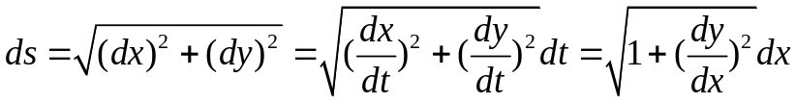
For i) a cure given by x=Asin(t), y=Acos(t), what is length if t is between 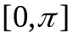 (the answer is of course straightforward that you know before doing integration, but do it anyway to check). ii) For a curve given by: 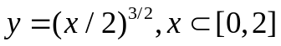, find its arc length.

- Simple 1st order differential equations (an application of integration)
- Exponential decay or growth: If the initial value (t=0)of some material (you money in bank; the C₁₄ isotope in fossil, the mass of a rain droplet during condensation, you name it) is A₀, and its changing with time at a constant rate kA, k is some proportional constant, i.e. dA/dt=kA, find the number of material after some time T, what is the time that the number dropped (this may require k > or < 0?)by a factor of e, and this time is usually called lifetime.
- The cooling of an egg. The temperature change can be approximated by heat dissipation and we shall approximate the dissipation is proportional to temperature difference between object and a sink (the sink’s temperature is kept at constant), i.e. dT/dt=-k(T-T₀) where T₀ is the temperature of the sink. For an egg boiled to 98 C, and was put into a water bath sink of 18C. After 5 minutes the egg was cooled to 38 C (the sink is always at 18C) and how much more time it will take for the egg to reach 20C?
You may also try the case (this is optional) that the sink is not a constant temperature but also rise as egg cools, (you will need to make assumptions such as heat capacity and total mass of the sink etc), and the calculation will be a coupled differential equations on temperatures.
- Draining a tank:
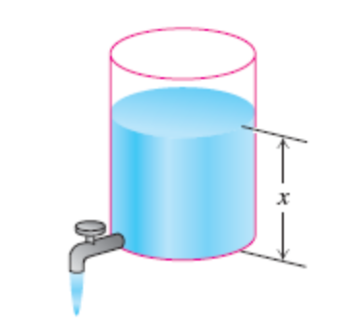
The draining of the water tank depends on the height of the water level, and the change of volume of water in the cylinder is 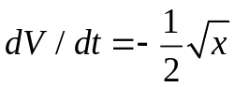, the radius of water is 5ft and the height is 16 ft initially, how long it will take to drain all the water?
- Bullet in air: The wind resistance that the bullet feels is proportional to its velocity, i.e. F=-kv (K is a constant, minus is because it is against bullet’s motion). If the initial velocity of the bullet is V₀, find the velocity relation over time, i.e. after time t how fast the bullet will travel; and how far the bullet had traveled after time t? What happened if the resistance force is 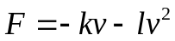 where is another positive constant?

